EE113D: Digital Signal Processing Design

Lab 2: Voice Transformation

**OBJECTIVE**

The objective of Lab 2 is to implement a DSP player & recorder by configuring the I/O pin & clock configurations of the Nucleo board and coding with inbuilt functions to sample and transform voice recordings. The lab consists of 4 parts: voice recording, reverb transformation, up sampling, and down sampling. In all of the components, the lab requires the use of signal processing techniques to properly modify the voice samples.

**DATA**

Voice Sampling

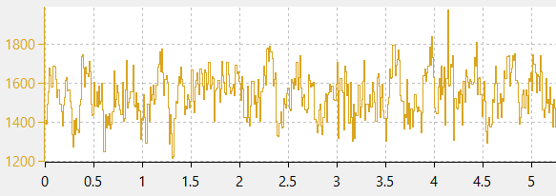

Fig. 1: Sample of voice recording with the word “demo” at 8kHz.

CODE:

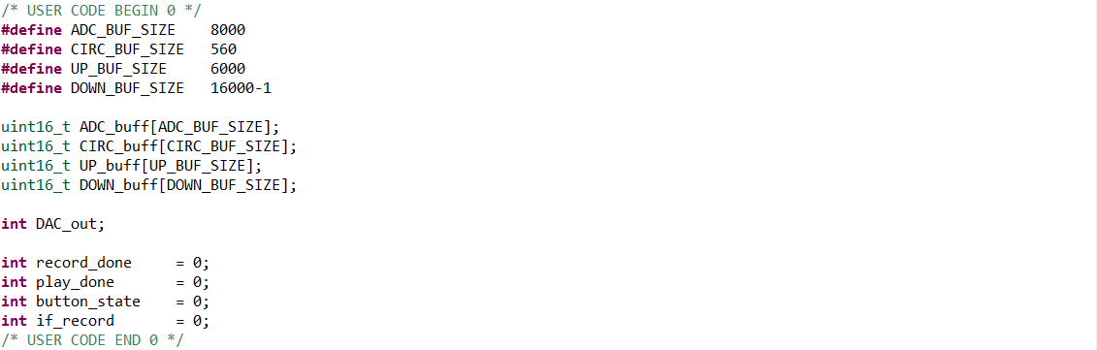

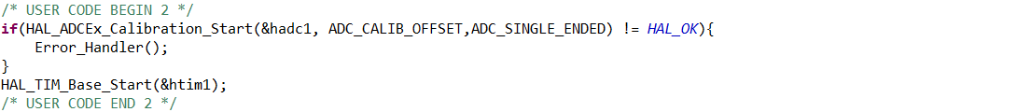

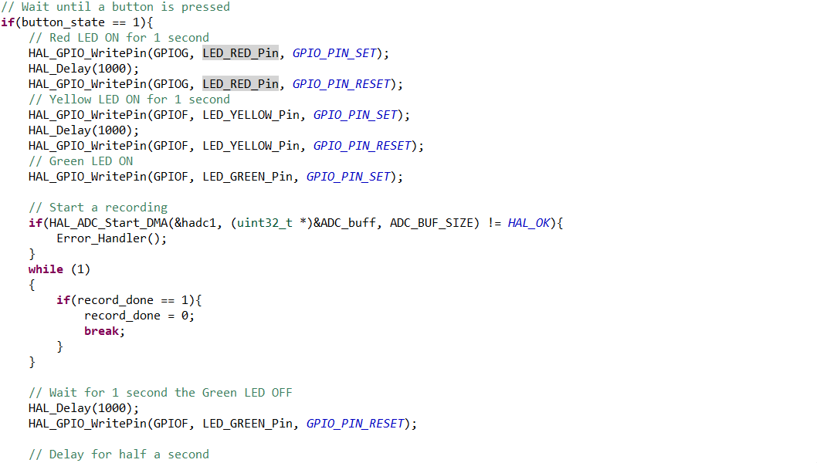

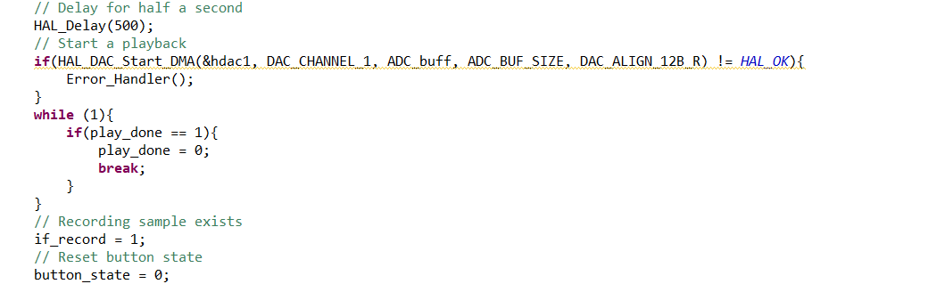

Reverb Effect

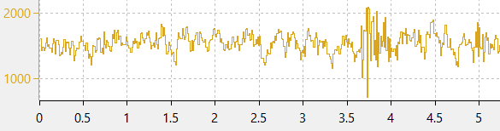

Fig. 2: Sample of voice recording transformed with a reverb effect.

CODE:

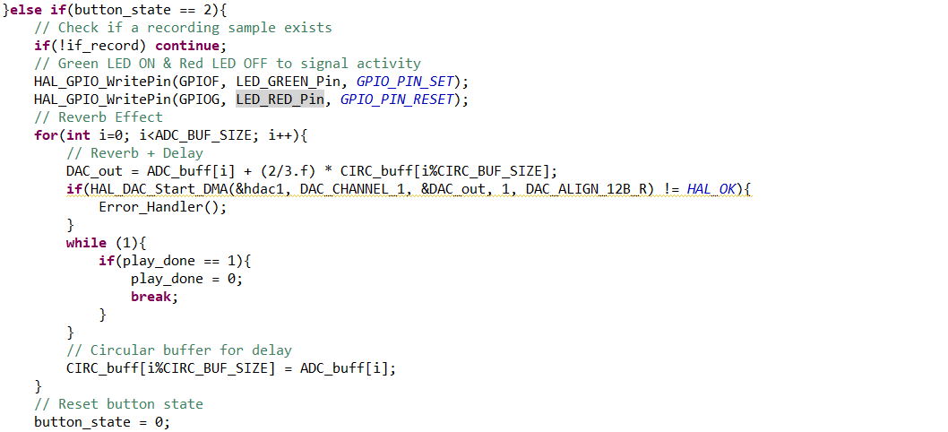

Up Sampling

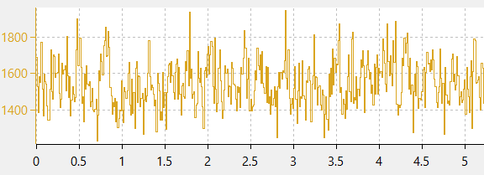

Fig. 3: Interpolated sample of voice recording speeded up by a factor of a third.

CODE:

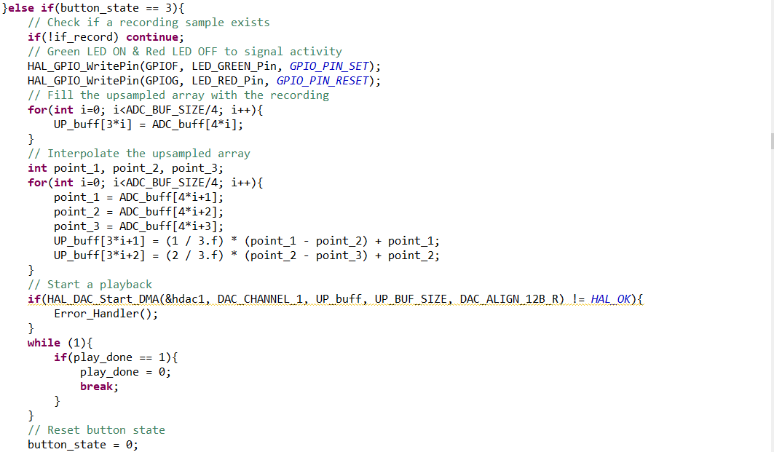

Down Sampling

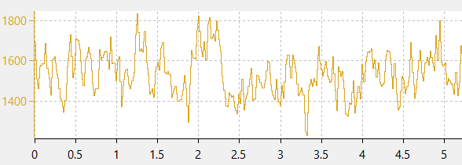

Fig. 4: Interpolated sample of voice recording slowed down by a factor of a half.

CODE:

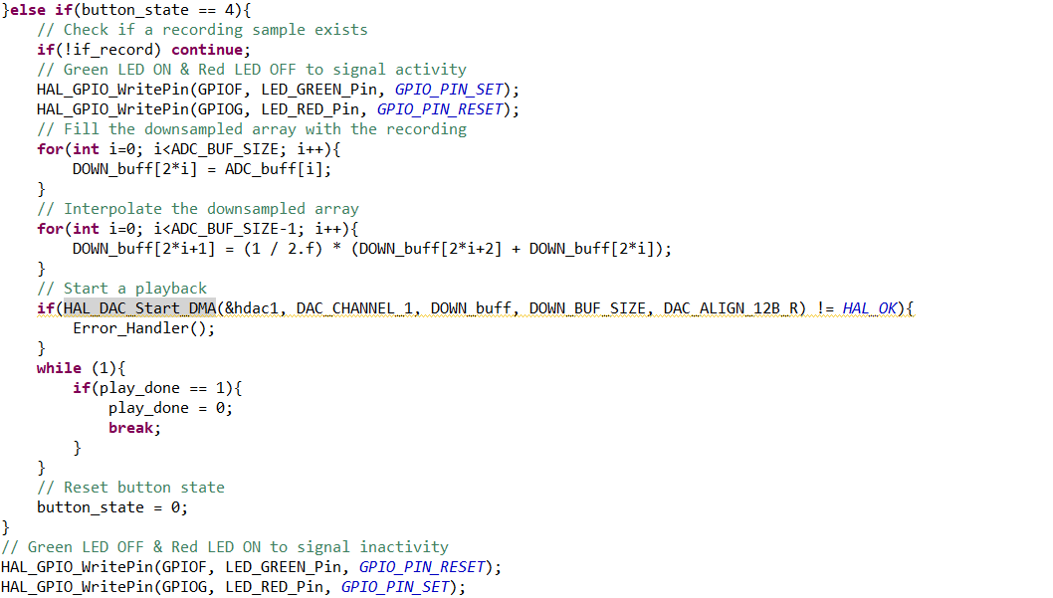

**RESULTS**

The results of the lab followed expectations and met the requirements to a sufficient degree. For example, the voice recordings and transformation audio outputs are clear, albeit with some environmental noise. With some windowing techniques applied to the Fourier Transform of the signals, the speaker would output clearer and less noisy sound. However, physical limitations of the equipment proved to be quite difficult to work with and costed significant time lost to debugging. For instance, the lack of proper solder connections between the microphone and the amplifier to the rest of the circuit resulted in unreliable audio measurements and distorted audio outputs. To solve this issue, the wire connections between the microphone and the rest of the circuit were routinely checked for loose connections. For future labs, soldering might be required if too many devices have crimp connections.